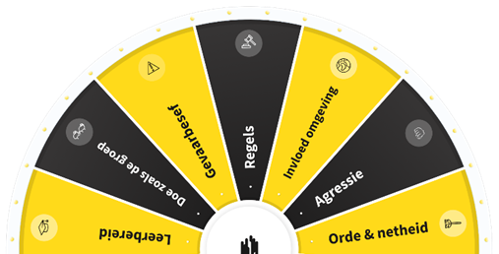

# **MANUAL FOR INSTRUCTORS** SAFETY GAME ‘WAVE ACCELERATOR’

Before you lies the manual for the safety game, of which you are the instructor! The theme of the 'WAVE accelerator' safety game is 'Gearing up safety! Will you help us to accelerate?’. The game is different from that of previous years. We have selected a number of topics with related questions. This year there are no answer options, no teams or points to score; the idea is to discuss everyone's experiences and motivations in the field of safety.

The intention is that, as in previous years, all VolkerWessels employees play the safety game together during the safety day. The game should preferably also be played with external parties.

WHAT DO YOU NEED?

You can project the game on a screen using a beamer or play it on a TV screen. In small groups the game can also be played on a laptop or tablet. Internet access (via WiFi or WiFi hotspot) is required. Open the application in the internet browser ‘Google Chrome’.

Don't have WiFi at the location where you are going to play the game? Read how you can set up a WiFi hotspot on your smartphone using the following link[: https://www.kpn.com/beleef/internet/wifi-hotspot-instellen-op-je-smartphone.htm](https://www.kpn.com/beleef/internet/wifi-hotspot-instellen-op-je-smartphone.htm)  
EXPLANATION OF THE GAME

(BEFORE STARTING THE GAME)

* Depending on the COVID-19 measures in place on 30 March, the game will be played physically or digitally.
* The game has a number of topics:
  + Willingness to learn;
  + Action;
  + Order and tidiness;
  + Supervisor's role;
  + Ambient influences;
  + Group behaviour;
  + Rules;
  + Hazard awareness;
  + Risk tolerance;
  + Overestimating your abilities;
  + Aggression at work;
  + Working at height.
* The game is played in groups of at least 6 and no more than 12 participants.
* There is one version of the game that can be played by internal staff as well as external parties.
* Log in at: <https://veiligheidsdag2022.volkerwessels.com/>
* The username for the Dutch version is: Veiligheid2022
* The password is: Versnel
* Usernames and passwords for other language versions can be found at the end of this manual.
* The tools can be consulted via the following link: <https://www.volkerwessels.com/veiligheidsdag_2022>

Test the game together with a number of colleagues before 30 March so that you know how it works.

START OF THE GAME AND TAKING TURNS

* Log in with your username and password.
* On the screen you now see the front of the digital game. This is a wheel with different topics.
* The game starts as soon as the employee whose turn it is clicks on the button.
* The wheel starts spinning and will stop on one of the topics.
* A question related to the relevant topic appears on the screen.
* As the instructor, you read the question aloud and ask someone to answer it (designate a different person to answer each question).
* As the instructor, you can ask questions to clarify an answer, if necessary.
* Then briefly discuss this topic/answer with each other.
* The following person spins the wheel for the next topic.
* Play the game for at least 45 to 60 minutes.

TIPS FOR THE INSTRUCTOR DURING THE GAME

* As the instructor, you are in charge. Make sure that everyone participates actively and that everyone gets their turn or at least is involved in the discussions.
* Ask open-ended questions to keep the discussion going. (such questions start with 'what', 'why' or 'who').
* Stay true to yourself and give the game a personal 'twist'.

**Have fun playing the game!**

QUESTIONS?

If you have any technical questions about the game, you can contact Recognize during office hours by phone at 074-760 0260 or email at [support@recognize.nl](mailto:support@recognize.nl)

If you have any questions about this manual and/or the safety game, please contact   
Bas Roordink and/or Fleur Buitink ([veiligheid@volkerwessels.com](mailto:veiligheid@volkerwessels.com)).

USERNAME AND PASSWORD

**Username Dutch version: Veiligheid2022**

**Username English version: Veiligheid2022_ENG**

**Username Polish version: Veiligheid2022_PL**

**Username Turkish version: Veiligheid2022_TUR**

**Username Romanian version: Veiligheid2022_ROE**

**Username German version: Veiligheid2022_DUI**

**Username Bulgarian version: Veiligheid2022_BUL**

**Username Portuguese version: Veiligheid2022_PT**

**Password for all versions: Versnel**